

**Department of Computing**

**BS Computer Science**

**NASTP Institute of Information Technology**

**Submitted By:** Maisum abbas (023)

**Submitted To:** Sir Ibaad Babar

**Semester:** II

**Session:** Fall - 2024

**Subject:** Data Structures

**Date of submission:** 8 Oct 2025

**Lab Report 2**

**Task1:**  
I created the static array and store given the data into it. And display using for loop

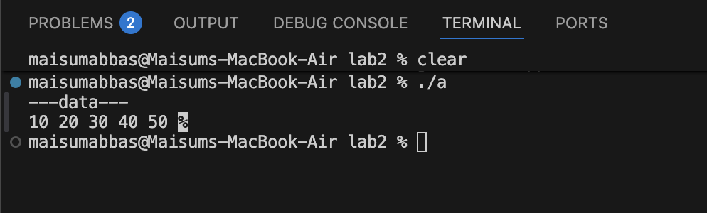

**Task2:**

Created the dynamic array and store multiple of 2 in it then using the for loop

To show the stored data to the user

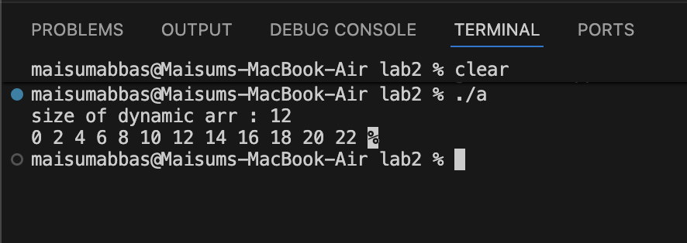

**Task3:**

Created the class and in it make a constructor to make the user input the data to be initialized at creation of object. Then created bulk of objects using array .

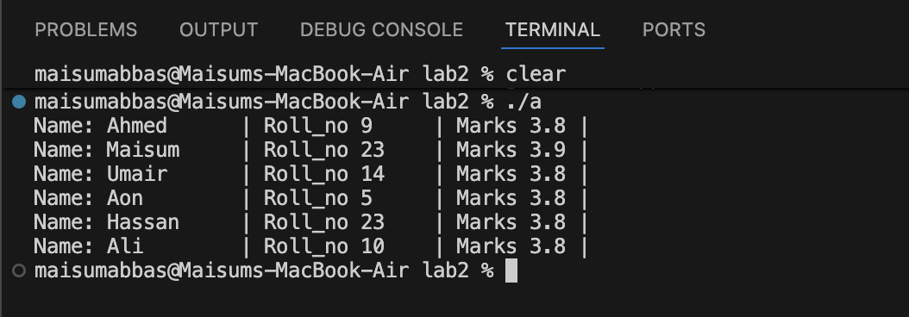

**Task4:**

Created the dynamic array and store the data into it as it has the size of in it . Then created the function and to print and function to reverse it

